


The Bluebell Federation


Attendance
Policy 2026 - 2027

Senior Attendance Champion/ Senior Leader responsible for the strategic approach to attendance:

Name Mrs Fiona Page
Email address or contact details head@littlehorsted.e-sussex.sch.uk

School staff member that pupils and parents should contact about attendance on a day-to-day basis is:

Name Mrs Natalie Reed
Email address or contact details office@littlehorsted.e-sussex.sch.uk

School staff member that pupils and parents should contact for more individual support with attendance (Attendance Officer etc):

Name Mrs Fiona Page
Email address or contact details head@littlehorsted.e-sussex.sch.uk

Linked Governor with responsibility for monitoring attendance is:

Name I’ll leave blank for the time being
Email address or contact details

Updated: August 2026 Due for review: August 2027

Ratified by the Governing Body: AMEND ACCORDINGLY Date:

The Bluebell Federation Attendance Policy

This Attendance policy is easily accessible to leaders, staff, pupils, and parents, and is published on the school’s website. When new pupils join The Bluebell Federation, parents are provided a copy with any initial information. At the beginning of each school year and following any updates, we will highlight this to our community.
Contents
Roles and Responsibilities for Attendance 7
Understanding Types of Absence 11
Persistent Absenteeism (PA) and Severe Absenteeism (SA) 13
Absence Procedures 14
Lateness 15
Understanding Attendance Barriers & Early Intervention 16
Pupils absent from school due to mental or physical ill health or SEN/Disabilities 17
Support Systems 18
Local Authority Attendance Support Team 18
School Attendance and the Law 19
Granting Leave of Absence – Withdrawal from Learning Application for Exceptional Circumstances 19
National Framework for Penalty Notices 20
Notices to Improve (NtI) 21
Attendance Contracts 21
Attendance Recognition & Interventions 21
Appendices 23
Appendix A: East Sussex County Council’s Penalty Notice Procedures for Schools and Academies 23
Appendix B: Attendance Policy Quick Guide for Parents (see below) 23
Appendix C: Attendance Codes (see below) 23
Appendix D: NHS Guidance: Is my child too ill for school? 23
Appendix E: East Sussex County Council Attendance Intervention Pyramid (see below) 23
Appendix F: East Sussex County Council Penalty Notice Code of Conduct for Unauthroised Absence (Youtube) 23
Appendix G: DfE & Children’s Commissioner: ‘Illness Absence Guidance’ for parents 23
Appendix H: DfE Guidance Summary Responsibilities for School Attendance 23
Appendix F: Attendance Management Flowchart 29

Background and Aims

At Little Horsted CE Nursery and Primary School, improving school attendance is a shared responsibility, and a priority that underpins every child’s right to learn, thrive and achieve, therefore benefiting their wider life chances. We value the attendance of all pupils. Missing out on lessons leaves children vulnerable to falling behind and can put them at risk of wider harm. As set out in this policy, we will work with families to identify the reasons for poor attendance and try to resolve any difficulties at the earliest opportunity possible. For our children to gain the greatest benefit from their education, it is vital that they attend regularly and be at school, on time, every day the school is open unless the reason for the absence is unavoidable.

For the most vulnerable pupils, regular attendance is also an important protective factor and the best opportunity for needs to be identified and support provided. Research has shown associations between regular absence from school and several extra-familial harms.

Aims: To give clear guidance to staff, parents, pupils, and governors about attendance to:
- Promote a positive and welcoming environment and culture in which pupils feel safe, secure, a sense of belonging and are valued.
- Promote strong attendance to support pupils’ achievement by maintaining the highest possible standards of attendance and punctuality.
- Acknowledge the vital role all staff play in encouraging/sustaining good attendance.
- Establish a clear system for monitoring and responding to pupil absence, taking prompt action to address emerging patterns.
- Build and maintain positive relationships with families to ensure pupils receive the support they need to attend school regularly.
- Encourage effective support structures and champion multi-agency collaboration to improve attendance outcomes.
- Ensure parents understand their legal responsibilities and that all children can access the education to which they are entitled.

This policy is based on the statutory guidance: DfE’s Keeping children safe in education, and Working together to improve school attendance.
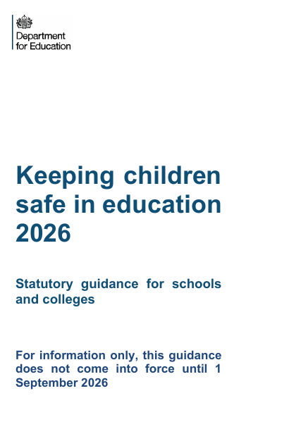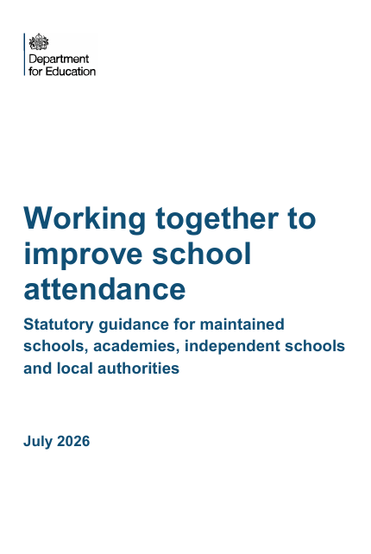
It should be read alongside the following statutory DfE guidance documents, and other East Sussex LA Attendance guidance:
- East Sussex Attendance Delivery Plan 2026 – 2027: Attendance | Czone
Providing remote education: guidance for schools (August 2024)
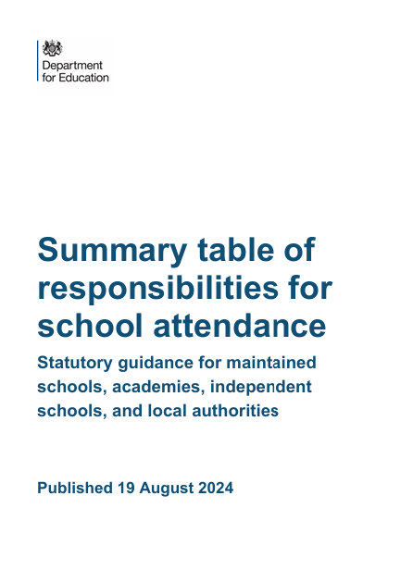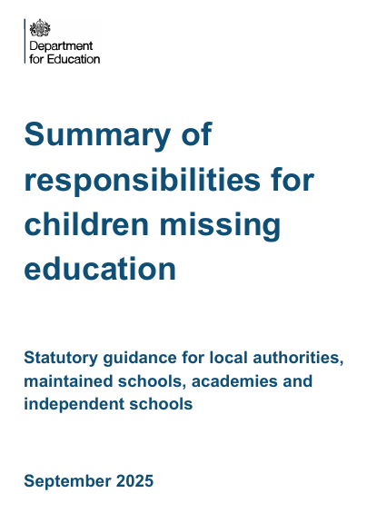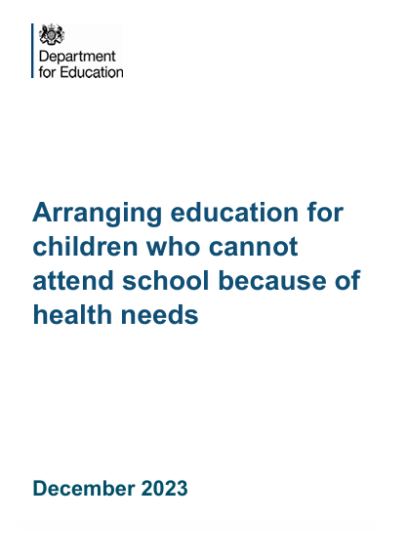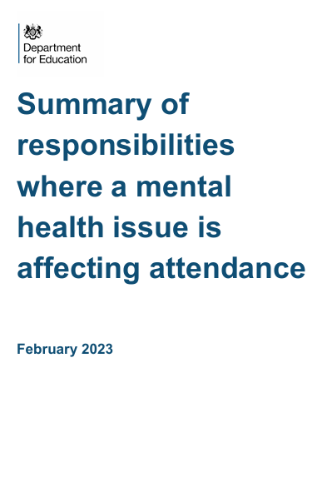
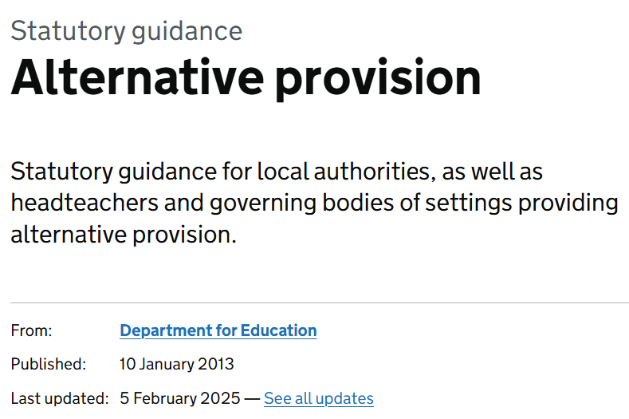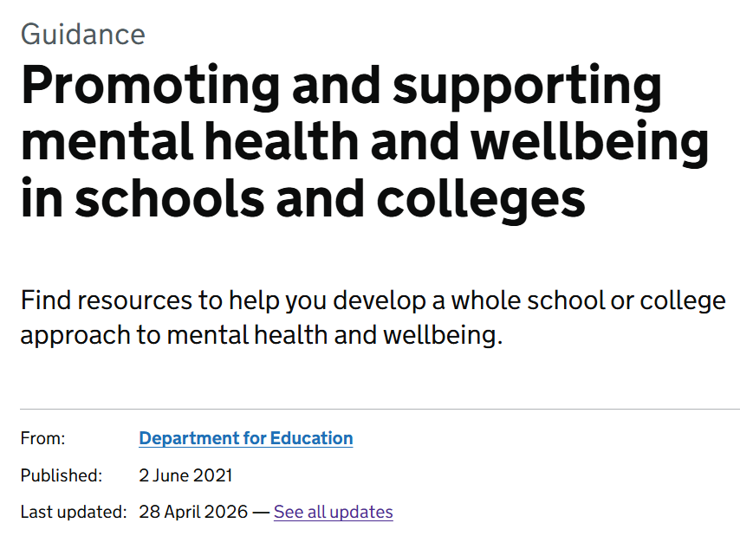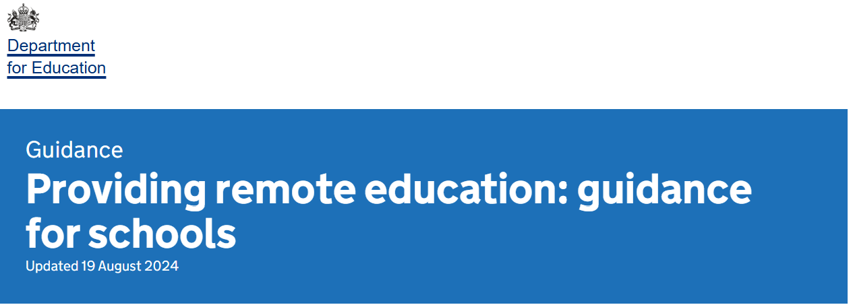

Our policy aims to raise and maintain levels of attendance in six steps:
- EXPECT: Promoting a positive and welcoming atmosphere in which pupils feel safe, secure and valued;
- Raising and maintaining a whole school awareness of the importance of good attendance and punctuality by aspiring to high standards for all pupils and families;
- MONITOR: Ensuring that attendance is monitored effectively and reasons for absences are recorded promptly and consistently, with registers taken at the same time for all children daily, twice in the school day;
- LISTEN and UNDERSTAND: Listening and understanding barriers to attendance from the pupil and family’s perspective and agree how all partners can work together to resolve them;
- FACILITATE SUPPORT: Outlining how the school’s Attendance Team will work with families to remove barriers in school and helping pupils and parents to access the support they need to overcome the barriers outside of school (i.e. Early Help Support or a whole family plan);
- FORMALISE SUPPORT: Formalise support where absence persists and voluntary support is not working or being engaged with;
- ENFORCE: Communicating the school’s duty to enforce statutory intervention i.e. a penalty notice or prosecution to protect the pupil’s right to an education.

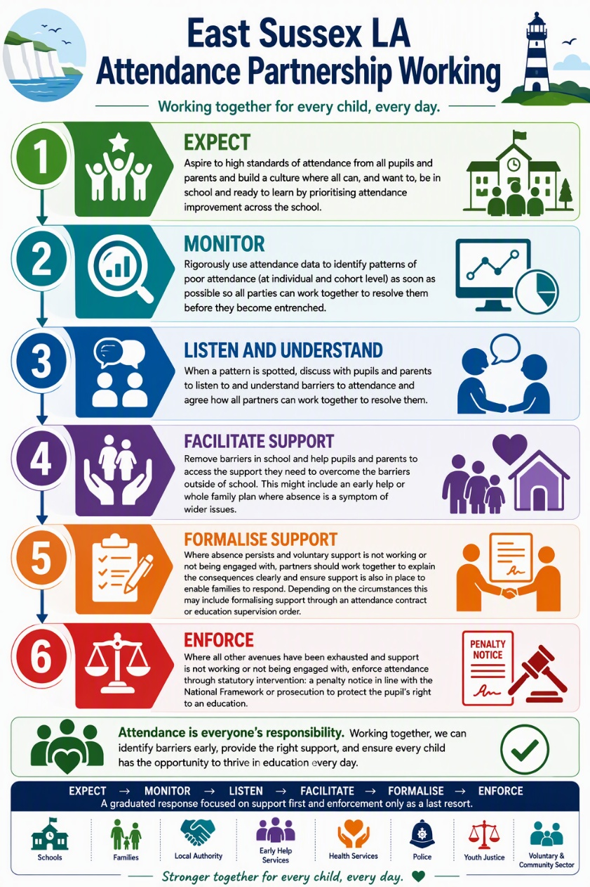

Roles and Responsibilities for Attendance
The government expects all parents and carers to:
- Ensure their child attends every day the school is open except when a statutory reason applies.
- Notify the school as soon as possible when their child is has unplanned absence (e.g. sickness).
- Only request leave of absence in exceptional circumstances and do so with good notice.
- Book any medical appointments outside of the school day where possible.

A “parent” is defined as:
- Any natural parent, whether married or not.
- Any parent who, although not a natural parent, has parental responsibility as defined in the Children Act (1989) for a child or young person.
- Any person who, although not a natural parent, has care of a child or young person.
- In accordance with the Education Act 1996, we will work with parents and the Local Authority to ensure that they are supported to secure education for children of compulsory school age. Where required, we will formalise support and where necessary, work with the LA to use legal measures.
The government expects all schools to:
- Build strong relationships and work jointly with families.
- Develop and maintain a whole school culture that promotes the benefits of good attendance, with high expectations of attendance for all pupils.
- Have a clear school attendance policy on the school website which all staff, pupils and parents understand.
- Accurately complete daily admission and attendance registers, at the same time each day for all pupils. Have robust daily processes to follow up absence.
- Regularly monitor data to identify patterns and trends and understand which pupils and pupil cohorts to focus on.
- Share information and work collaboratively with other schools in the area, LA and other partners where a pupil’s absence is at risk of becoming persistent or severe.
- Be particularly mindful of pupils absent from school due to mental or physical ill health or their special educational needs and/or disabilities and provide them with additional support.
- Recognise the importance of good attendance and, alongside good behaviour, make it a central part of the school’s vision, values, ethos and day to day life.
- Have a dedicated senior leader with overall responsibility for championing and improving attendance, who ensures all staff are trained on attendance matters.

At The Bluebell Federation, to manage and improve attendance effectively, we will:



The government expects all local authorities to:
- Rigorously track local attendance data.
- Have a School Attendance Support Team, with a named single point of contact (SPOC) to provide core functions: communication and advice and targeted support meetings (TSMs).
- Offer multi-disciplinary support for families at the earliest opportunity.
- Support schools with legal intervention, using the full range of parental responsibility measures) where voluntary support has not been successful or engaged with.
- Monitor and improve the attendance of children with a social worker through their Virtual School, and that of young carers.

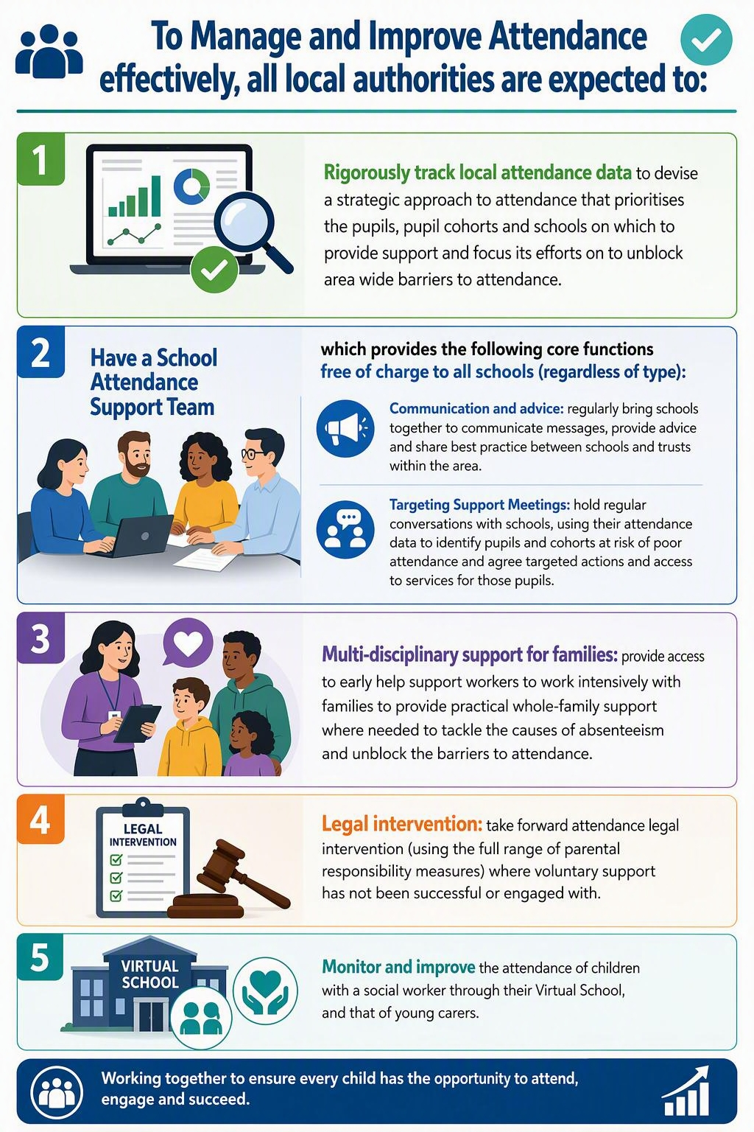

Helping to create a pattern of regular attendance is the responsibility of parents, pupils and all members of The Bluebell Federation staff.

To help us all to focus on this at The Bluebell Federation, we will:
- Submit a daily attendance return to the Department of Education, in line with the legal expectations placed on all schools.
- Monitor attendance data rigorously to implement effective early intervention;
- Build strong relationships and work jointly with families, listening to and understanding barriers to attendance and working in partnership to remove them.
- Accurately complete admission and attendance registers at the same time each day, and have effective day-to-day processes in place to follow-up absence as required by law.
- Give parents/carers details on attendance in our newsletters and website, providing clarity about the individual circumstances in which leave of absence may be granted;
- Be transparent with families about the legal intervention available to The Bluebell Federation which is enforceable for unauthorised absence where voluntary support has not been successful or engaged with.
- Share information and work collaboratively with the local authority, other schools and other local partners where a pupil’s absence is at risk of becoming persistent or severe;
- Share attendance data regularly to the Governors to enable strategic improvements for our pupils.
- Promote the benefits of high attendance; (see Appendix L)
- Celebrate excellent attendance by displaying and reporting individual and class achievements
- Reward children with ‘improved’ attendance (however big or small) extra marbles for jar/sticker/house points.
- Report to parents/carers regularly on their child’s attendance and the impact on their progress,
- Share information and work collaboratively with other school in the area, East Sussex local authority, and other partners where a pupil’s attendance is at risk of becoming persistent or severe absent.
- Contact parents/carers should their child’s attendance fall below the school’s target for attendance. Where absence intensifies, the level of support provided by school will also increase, to work in tandem with East Sussex LA and other partners.
- Ensure that all new parents are introduced to the Attendance Policy and information on attendance will be in the school welcome pack.
- Issue an Amazing Attendance Information leaflet for parents (See Appendix I)
- Individual parents will be approached where there is concern about their child’s attendance or punctuality.
- Birthdays are celebrated in school with birthday sashes, candles, a birthday card and a line pass
- Hold regular Attendance Challenge days/weeks- with prizes for individuals and classes (prizes special activities, not additional play)

School Staff Roles and Responsibilities (Please see Appendix J)

All staff, every day, will:
- Promote the importance of attendance and punctuality every day.
- Welcome pupils, notice when something doesn’t feel right and let someone know.
- Promote good attendance in interactions with pupils and parents through phone calls, emails, face-to-face and tapestry.
- Work to foster a sense of belonging with all pupils.
- Build positive relationships with pupils and families and create a safe, inclusive environment where pupils want to be.
- Use the language ‘We missed you and are so pleased to see you’ when children have been off school.
- Follow school procedures for attendance, absence and punctuality.
- Share any concerns about attendance or wellbeing early.

The Senior Attendance Champion will:
- Champion a culture where attendance is a priority and every child belongs.
- Monitor whole school attendance data, trends and patterns regularly.
- Meet with teachers 6 times a year to discuss the attendance of pupils in their class and agree next steps/actions.
- Coordinate early interventions and escalating support for pupils and families.
- Work directly with families when attendance concerns increase.
- Listen to barriers and agree support, including Attendance Support Plans and reasonable adjustments.
- Oversee requests for Withdrawal from Learning – all requests must have a discussion with parents before they are authorised or unauthorised.
- Work with external partners and the Local Authority Attendance Support Team when needed.
- Ensure staff receive the training and guidance the need to support good attendance.
- Report attendance information to Governors regularly.

All teaching staff will:
- Take accurate registers at the start of every session and by the correct time.
- Play a vital role in promoting good attendance.
- Monitor and note the attendance within their class and be alert to any patterns or changes.
- Build strong relationships with pupils and families and create a welcoming classroom culture.
- Speak to pupils about the importance of attendance and celebrate good attendance and improvement.
- In upper KS2, create safe and comfortable conversations with individual pupils about improving attendance.
- Sharing attendance information with parents at all parent consultations and on all school reports.
- Discuss pupil attendance during pupil progress meetings and contribute to agreed actions
- Send a friendly email to pupils (via Arbor) on the second day of absence onwards.

All office staff will:
- Check registers daily and ensure they are completed at the same time for all pupils each day and accurately record reasons for absence.
- Follow up any ‘lates’ or unexplained absence.
- Record reasons for absence and lateness promptly and accurately on Arbor.
- Contact all parents by the telephone to discuss the reasons for absence on the first day of absence, even if they have sent a message via email, Arbor or on the answerphone.
- Monitor attendance and lateness data and share any concerns with the Senior Attendance Champion/ Attendance Lead.
- Maintain accurate records, letters and communication.
- Ask for evidence of medical appointments.

Inclusion Lead will:
- Work with pupils and families who face additional barriers to attendance (for example, SEND, medical needs, anxiety)
- Ensure reasonable adjustments are in place to support access and reduce barriers.
- Coordinate support from outside agencies and Teams Around Schools where appropriate.
- Monitor the impact of support and interventions for pupils with additional needs.
- Provide advice and training to staff to increase understanding and inclusive practice.

All Governors will:
- Understand and promote the importance of good attendance across the school.
- Receive regular attendance data and reports from leaders.
- Monitor attendance trends, challenge when necessary and celebrate success.
- Ensure the school’s attendance policy and practice are effective and up to date.
- Ask questions and hold leaders to account for improving attendance for all pupils.

Here at The Bluebell Federation we treat school attendance as a vital safeguarding issue, not just a pastoral or administrative matter. We expect pupils to achieve attendance of 96% or above wherever possible.

We request that parents:
- Ensure their child attends school every day and arrives on time by 8.50am
- Report any instance of absence by 9:15am on the first day and every day thereafter, if applicable with verbal contact.
- Inform the school of the reason for absence and the expected date of return, following this with a note wherever possible for example evidence of medical appointments (screen shots of text messages with appointments etc are acceptable evidence)
- Avoid unnecessary absences, for example, by making medical and dental appointments outside of school hours / school holidays.
- Ask the school for help if their child is experiencing difficulties with any aspect of their schoolwork or home and family life. Act early to ensure we can work collaboratively to resolve issues before they escalate.
- Inform the school of any change in circumstances that may impact negatively on their child’s attendance.
- Attend all meetings requested to discuss attendance issues.
- Work with the school to improve their child’s attendance where necessary.

We request that pupils:
- Speak to a trusted adult if they are experiencing issues with their attendance.
- Attend all lessons on time and are ready to learn.
- Follow the school procedure if they arrive late. This will help the school to monitor attendance and keep accurate records for the child’s individual attendance. This is also vital for health and safety in the event of a school evacuation.

Understanding Types of Absence
Any absence affects the routine of a child’s schooling and regular absence will seriously affect their learning journey and ability to progress. Any pupil’s absence or late arrival sets them up for a disrupted start to their day, disrupts teaching routines and so may affect the learning of others in the same class.

Ensuring a child’s regular attendance at school is a parental responsibility and allowing absence from school, without a good reason, creates an offence in law and may result in prosecution.

Sessions
Every half-day absence from school has to be classified by the school (not by the parent), as either authorised or unauthorised. This is why information about the cause of any absence is always required. Each half-day is known as a ‘session’.

Authorised Absence
Authorised absences are morning or afternoon sessions away from school for a genuine reason such as illness (you will be asked to provide medical evidence for your child before this can be authorised), medical or dental appointments which unavoidably fall in school time, emergencies or other unavoidable cause. Please note, in the first instance, the school will always endeavour to request you to seek medical or dental appointments outside of the school day/holiday where possible.

Unauthorised absence
Unauthorised absences are those which the school does not consider reasonable and for which no ‘leave’ has been granted. This type of absence can lead to the school referring to the Local Authority for penalty notices and/or legal proceedings.

Unauthorised absence includes, (however this list is not exhaustive):
- parents/carers keeping children off school unnecessarily e.g. because they had a late night or for non-infectious illness or injury that would not affect their ability to learn.
- absences which have never been properly explained.
- children who arrive at school after the close of registration are marked using a ‘U’. This indicates that they are in school for safeguarding purposes, however is counted as an absence for the session.
- shopping trips.
- looking after other children or children accompanying siblings or parents to medical appointments.
- their own or family birthdays.
- holidays taken during term time, not deemed ‘for exceptional purposes’ by the Head of School, including any arranged by other family members or friends.
- day trips.
- other leave of absence in term time which has not been agreed.

Appendix H outlines the DfE Guidance Summary Responsibilities for School Attendance for parents, schools, trusts and local authorities.

Persistent Absenteeism (PA) and Severe Absenteeism (SA)
Persistent Absenteeism (PA) – 90% attendance and below
- A pupil is defined by the Government as a ‘persistent absentee’ when they miss 10% or more (equivalent to 1 day or more a fortnight across a full school year) schooling across the school year for any reason; this can be authorised or unauthorised absence.
- Absence at this level will cause considerable damage to any pupil’s education and we need the full support and co-operation of parents to resolve this.
- All pupils who have attendance levels of 90% or below are considered to be a persistent absentee.
- Through careful monitoring, where attendance drops below 92%, the school will initiate working closely with families to mitigate attendance falling to persistent absent levels (below 90%).
- All persistent absent pupils will be expected to meet with the school’s attendance champion to implement informal support, and where appropriate, an Attendance Support Plan will be developed collaboratively.
- Information (Youtube clip) on East Sussex County Council’s Penalty Notice Code of Conduct for Unauthorised Absence can be found in Appendix F. NHS guidance related to ‘Is my child too ill for school?’ can be found in Appendix D. These aim to provide parents with helpful information to support school attendance.
Severe Absenteeism (SA) – 50% attendance and below
- A pupil who has missed 50% or more schooling is defined by the Government as ‘severely absent’.
- These pupils are absent from school more than they are present. Pupils within this cohort may find it more difficult to be in school or face bigger barriers to their regular attendance and, as such, are likely to need more intensive support.
- All severe absent pupils will have a bespoke attendance plan in place, in conjunction with working multi-agency support.
Formalising Attendance Support with East Sussex LA
- If all avenues of support have been facilitated by schools, the local authority, and other partners, and the appropriate educational support or placements (e.g. an education, health and care plan) have been provided but severe absence for unauthorised reasons continues, it is likely to constitute neglect.
- The Bluebell Federation has a clear strategy for reducing PA and SA through accessing wider support services to support removing barriers to attendance and formalising support in conjunction with East Sussex LA. The Bluebell Federation may exercise its right to pursue legal intervention using the full range of parental responsibility measures. See Appendix E for the Attendance Intervention Pyramid.
The full range of legal interventions include:
- Penalty notices (a Notice to Improve is a final opportunity for parents to engage in attendance support before a penalty notice)
- Attendance Contracts
- Education Supervision Orders (ESO)
- Attendance prosecution
- Parenting Orders

Absence Procedures
We monitor and review all pupils’ absence, and the reasons that are given, thoroughly, as part of our statutory duty to the Department of Education.

Absence Procedures:
- If your child is absent, contact the school on the first day of absence before 9.15 am, when our register closes. Our afternoon session starts at 1pm. Attendance registers will be taken at the same time each day, regardless of circumstances.
- The school has an answer phone available to leave a message if nobody is available to take your call, or you may call into school personally and speak to the office staff –Please be aware that, if you leave a voicemail to report your child’s absence, you will receive a call from the school so that we can discuss the absence before making a decision as to whether the absence is to be recorded as authorised;
- Contact the school on every further day of absence, again before 9.15 am; please note that where a school has not had confirmation of the whereabouts of absent pupils, a welfare check may be made to the home to investigate any unexplained absences as part of our legal safeguarding duty;
- Ensure that your child returns to school as soon as possible and you provide any medical evidence, if requested, to support the absence. Medical evidence may be requested where your child is having multiple periods of absence which are reported as being due to medical reasons. When determining whether a child is too ill to attend school, both parents and school staff can consider the advice contained within the NHS and East Sussex County Council Guidance on School Absence and Childhood Illness [What to do if your child is ill | East Sussex County Council]. Also see Appendix D: NHS Guidance: Is my child too ill for school? And Appendix G: DfE and Children’s Commissioner ‘Illness Absence Guidance’.

If your child is absent we will:
- Telephone you on the first, and every subsequent day of absence, if we have not heard from you. However, it is your responsibility to contact us.
- If we are unable to make contact with parents by telephone, we will telephone emergency contact numbers, send letters home and a home visit may be made, as part of the school’s safeguarding duty. Please ensure all contact details, including emergency contact details are kept up to date.
- A referral will be made to East Sussex Local Authority if no contact has been made with parents by the 10th day of absence (or sooner if deemed appropriate), at which point your child will be considered to be “missing from education.”
- For anticipated absences for exceptional circumstances, parents are required to complete a ‘Withdrawal from Learning Application for Exceptional Circumstances’ form (Appendix A), at least 2 weeks ahead of the absence. This will allow the Head of School to call you to discuss the absence, then complete the necessary paperwork and communicate a response, whether authorized or unauthorised. Where parents have not made an application, all absences will be unauthorised.
If absence continues we will:
- Write to you if your child’s attendance is below 95% and/or where punctuality is a concern.
- Arrange a meeting so that you may discuss the situation with our Senior Attendance Champion.
- Create a personalised action/support plan, such as an Attendance Contract (Appendix A), to address any barriers to attendance and make clear each person’s role in improving the attendance patterns of your child.
- Offer signposting support to other agencies or services, if appropriate (Appendix D and G).
- Refer the matter to East Sussex Local Authority for relevant legal sanctions, if attendance deteriorates following the above actions (Appendix E).
If your child is feeling ‘Under the Weather’ but well enough to attend school, we will:
- Ask parents or carers to complete a short form where a child is feeling mildly unwell (‘under the weather’) but can still attend school. (See Appendix K)
- When a form is submitted:
- A trusted adult will check how the pupil is feeling at points through the day
- If symptoms worsen, appropriate action will be taken, e.g. seeking medical advice if required and/or arranging for the pupil to go home.
This approach can help reassure parents and pupils enough to give school a go, when otherwise the pupil might have stayed at home

Lateness
Poor punctuality is not acceptable and can sometimes lead to irregular school attendance patterns. Good time-keeping is a vital life skill which will help children as they progress through their school life and out into the wider world. Pupils who arrive late disrupt lessons and, if a child misses the start of the day, they can feel unsettled and embarrassed and risk missing vital work and important messages from their class teacher.

The times of the start and close of the school day for all pupils at Little Horsted CE Primary School are:
Gates open: 8.40am
Registration starts: 8.50am
End of the school day: 3.25pm
Registers will be taken at the same time each day for all pupils.

How we manage lateness:
- The school day starts at 8.40am when children can begin to come into school;
- Registers are taken at 8.50am when the gate closes;
- Children arriving after 8.50am are required to come into school via the school office. They must be accompanied by a parent/carer who must sign them into our ‘Late Book’ and provide a reason for their lateness, which is recorded.
- Please note it is not possible for children to arrive during 9am and 9:15am as the office is closed during this time to allow the office to make contact with any absentees.
- At 9.20am the registers will be closed. In accordance with the Regulations, if your child arrives after that time, they will receive a mark that shows them to be on site – ‘U’, but this will not count as a present mark and it will mean that they have an unauthorised absence;
- The school may contact parents regarding punctuality concerns; as ‘U’ codes count towards unauthorised absence, 10 lates could trigger the school issuing a penalty notice and/or legal proceedings to East Sussex County Council so it is imperative that morning routines provide ample time to arrive on time by 8.50am.
- If your child has a persistent lateness record, you may be asked to meet with the Head of School or Senior Leader, but you can approach us at any time if you are having difficulties getting your child to school on time. We expect parents and staff to encourage good punctuality by being good role models to our children and, as a school, we celebrate good class and individual punctuality.
- When registers are taken, the appropriate national attendance and absence code (Appendix C) must be entered for every pupil (of both compulsory and non-compulsory school age) whose name is listed in the admission register at the time. The codes enable schools to record and monitor attendance and absence in a consistent way and are used to collect statistics. The data helps schools, local authorities, and the government gain a greater understanding of the delivery of education and the level of, and reason for, absence. We will ensure that the consistent use of the attendance register and codes, including dual registration, flexi-schooling, no fixed abode, access arrangements, and when specific codes (e.g. Q, D, Y6, U) should be applied.

Attendance in the Nursery
Parents of children in the nursery must contact the school to tell them of their child’s absence in line with the procedures outlined above for the whole school.
- If your child is absent, contact the school on the first day of absence before 9.20 am, when our register closes. Our afternoon session starts at 12pm. Attendance registers will be taken at the same time each day, regardless of circumstances.
- The school has an answer phone available to leave a message if nobody is available to take your call, or you may call into school personally and speak to the office staff –Please be aware that, if you leave a voicemail to report your child’s absence, you will receive a call from the school so that we can discuss the absence before making a decision as to whether the absence is to be recorded as authorised;
- Contact the school on every further day of absence, again before 9.20 am; please note that where a school has not had confirmation of the whereabouts of absent pupils, a welfare check may be made to the home to investigate any unexplained absences as part of our legal safeguarding duty.

Schools with nurseries will follow up on absences in a timely manner. If a child is absent for a prolonged period of time, or if a child is absent without notification from the parent and/or carer, attempts will be made to contact the child’s parents and/or carers and alternative emergency contacts.

Schools with nurseries will consider patterns and trends in a child’s absences and their personal circumstances and use their professional judgement when deciding if the child’s absence should be considered as prolonged. Consideration will be given to the child’s vulnerability, parent’s and/or carer’s vulnerability and their home life. Any concerns must be referred to local children’s social care services and/or a police welfare check requested.

If a child’s attendance falls below 75%, an attendance meeting will be held between the parents and the Senior Attendance Champion. Please note that potentially the child’s place at the nursery will be suspended if attendance does not improve.

Understanding Attendance Barriers & Early Intervention
Early intervention is key to providing the right support at the right time. Whilst any child may occasionally have time off school because they are too unwell to attend, sometimes they can be reluctant to attend school. NHS Every Mind Matters provides effective support for mental health.

Any barriers preventing regular attendance are best resolved between the school, the parents and the child. If a parent thinks their child is reluctant to attend school, then we will work with that family to understand the root problem and provide any necessary support at the earliest convenience.

We can use outside agencies to help with this, such as:
- the School Nurse,
- Mental Health and Emotional Wellbeing support services,
- Early Help Key Worker team,
- a Family Support Worker or
- the relevant East Sussex Local Authority Attendance Support Team (AST/SPOC)
Where outside agencies are supporting the family, you may be invited to attend a meeting to consider what is working well and what needs to improve. An individual support plan will be agreed and subsequently reviewed. We will work with families to support pupils back into school following a lengthy or unavoidable period of absence and provide support to build confidence and bridge gaps.

Pupils absent from school due to mental or physical ill health or SEN/Disabilities
Some pupils face greater barriers to attendance than their peers. These can include pupils who suffer from long-term medical conditions or who have special educational needs and disabilities, or other vulnerabilities. High expectations of attendance remain in place for these pupils, however we will work with families and pupils to support improved attendance whilst being mindful of the additional barriers faced. We can discuss reasonable adjustments and additional support from external partners, where appropriate.

Under the DfE’s statutory guidance, schools are required to submit a sickness return to the Local Authority for all pupils who have missed/are likely to miss 15 or more school days (consecutive or cumulative) due to medical reasons/illness.

Anxious Feelings
Many children may experience normal but difficult emotions that make them nervous about attending school, such as worries about friendships, schoolwork, examinations or variable moods. These pupils are still expected to attend school regularly – in many instances, attendance at school may serve to help with the underlying issue as being away from school might exacerbate it, and a prolonged period of absence may heighten anxious feelings about attending in future. We will work alongside families to ensure that such circumstances do not act as a barrier to regular attendance by mitigating anxious feelings in school as much as possible. Some useful DfE’s non-statutory guidance on mental health issues affecting a pupil’s attendance can be found here Mental health issues affecting a pupil's attendance: guidance for schools - GOV.UK and Children's mental health - Every Mind Matters - NHS

Complex Barriers – physical or mental ill health
Some pupils face more complex barriers to attendance, for example: pupils who have long term physical or mental health conditions or who have special educational needs and disabilities (SEND). Their right to an education is the same as any other pupil and therefore the attendance ambition for these pupils should be the same as it is for any other pupil where the school may need to provide additional support. Keeping the school updated with any relevant information or need will enable the implementation of support through other agencies, at the earliest opportunity.

To support long term physical or mental ill health, the school will:
- Facilitate any relevant pastoral support with the clear aim of improving attendance, whilst supporting the underlying health issue.
- Consider adjustments to practice and policies to help meet the need of pupils struggling to attend, and make formal reasonable adjustments. Adjustments are agreed and regularly reviewed with the pupil and parents.
- Consider a time-limited phased return to school.

Support Systems
We recognise that poor attendance can be an indication of difficulties in a family’s life. This may be related to problems at home and or in school. Parents are encouraged to inform school of any difficulties or changes in circumstances that may affect their child’s attendance and/or behaviour in school, for example: bereavement, divorce/separation, emerging health concerns, housing issues, mental health concerns etc. This will help the school to identify any additional support that may be required.

We also recognise that some pupils are more likely to require additional support to achieve good attendance. The school will implement a range of strategies to support improved attendance based on the individual needs and circumstances of the child.

Strategies we may use to support you include:

- Holistic Support - We will work with families to understand and remove barriers to attendance (e.g., minor ailments, medical conditions, SEND, or bullying). The Senior Attendance Champion, along with the Inclusion Lead where necessary, will meet with parents and pupils to identify the barriers and form an attendance support plan. This plan is non-judgemental and supportive to work towards removing the barriers to attendance.
- Early Intervention - Rather than waiting for absence to become severe, we will use data to monitor patterns, conduct regular reviews, and implement joint action plans with parents. At Little Horsted, we will make reasonable adjustments to help improve attendance: this might be coming into school slightly earlier than when the gate opens to avoid large crowds; coming into school in own clothes and changing at school; soft starts (for example using the Sensory Room). We may also contact external agencies, such as Teams Around Schools (TASS), who help support attendance and can signpost families to other strategies to help at home and school.
- Clear Communication - We will use positive, clear, and consistent messaging to set expectations and celebrate attendance improvements. We will send out the Amazing Attendance information poster to all parents so that they are clear with the school’s expectations around attendance and the process when reporting absence. The children will be celebrated when their attendance improves through extra marbles in the class jars and additional house points. Private messages through Arbor, sent from class teachers, will inform parents of their child’s improvements in attendance. This will also be communicated in their reports. Overall class attendance for each week will be share on the school newsletter every two weeks.
- Collaboration - If your child is struggling to attend, parents should reach out to the school's senior leader responsible for attendance to establish what help and adjustments can be put in place. The Senior Attendance Champion is Mrs Page who has an open-door policy.

To plan the correct support, we will always invite parents and pupils to attend a meeting to discuss the concerns and devise a plan to support the child’s regular attendance. Support offered to families will be child-centred and planned in discussion and agreement with both parents and pupils.

Local Authority Attendance Support Team
Local Authority Attendance Support Team (AST) work strategically by offering support, advice and guidance to schools, to reduce persistent absence and improve overall attendance. Parents are expected to work with the school and local authority to address any attendance concerns. Parents should proactively engage with the support offered, aiming to resolve any problems together. This is nearly always successful. If difficulties cannot be resolved in this way, the school may consider more formal support and/or refer the child to the Local Authority. If attendance does not improve, legal action may be taken in the form of a Penalty Notice (see Appendix E: Attendance Intervention Pyramid and Appendix F: East Sussex Penalty Notice Code of Conduct) or prosecution in the Magistrates Court.

School Attendance and the Law
The School Attendance (Pupil Registration) (England) Regulations 2024 introduced a National Framework in England. By law all children of compulsory school age must receive an appropriate full-time education (Education Act 1996). Parents have a legal duty to ensure their child attends school regularly at the school at which they are registered.

Parents may be recognised differently under education law, than under family law. Section 576 of the Education Act 1996 states that a ‘parent’, in relation to a child or young person, includes any person who is not a parent (from which can be inferred ‘biological parent’) but who has parental responsibility, or who has care of the child.

A person typically has care of a child or young person if they are the person with whom the child lives, either full or part time and who looks after the child, irrespective of what their biological or legal relationship is with the child.

Granting Leave of Absence – Withdrawal from Learning Application for Exceptional Circumstances
- For anticipated absences for exceptional circumstances, parents are required to complete a ‘Withdrawal from Learning Application for Exceptional Circumstances’ form (Appendix A), a minimum of 2 weeks ahead of the absence. This will allow the Head of School to complete the necessary paperwork and communicate a response to parents, whether authorized or unauthorised. Where parents have not made an application, all absences will be unauthorised.
- Only a Head of School may grant a Withdrawal from Learning Application for Exceptional Circumstances at their discretion, for exceptional circumstances. Where every application will be considered on its individual merits, we do not operate a blanket policy that results in leave of absence being granted automatically.
- Exceptional circumstances considering specific facts and relevant background context behind the request will be considered.
- Where a Withdrawal from Learning Application for Exceptional Circumstances has been approved, the Head of School will determine the length of time the pupil can be away from school as authorised absence.
- Where a Withdrawal from Learning Application for Exceptional Circumstances has been taken without permission, this absence is unauthorised.
- All penalty notice communication between parents and school and information related to penalty notices procedures can be found in Appendix A, along with a useful Youtube video from East Sussex County Council Code of Conduct for Unauthorised Absence (Appendix F).
- In line with DfE’s guidance on (‘Providing remote education’) remote education should only be used as a last resort and as part of a reintegration plan.

National Framework for Penalty Notices
There is no entitlement in law for pupils to take time off during the term to go on holiday or other absence for the purpose of leisure or recreation, or to take part in protest activity in school hours, regardless of individual needs. The Supreme Court has ruled that the definition of regular school attendance is “in accordance with the rules prescribed by the school.”

Exceptional Circumstances
The School Attendance (Pupil Registration) (England) Regulations 2024 set out the statutory requirements for schools. All references to family holidays and extended leave have been removed. The amendments specify that Heads of School may not grant any leave of absence *Withdrawal from Learning Application’ (Appendix A) during term time unless there are "exceptional circumstances".

The fundamental principles for defining ‘exceptional circumstances’ are that they are ‘rare, significant, unavoidable and short’. When making absence-related decisions, the head teacher will consider:
- a pupil’s record of attendance for the current and previous academic years.
- time of absence being taken in the school year. If the request is made to extend the beginning or end of a school holiday period, it is unlikely to be considered exceptional.

10 in 10 Threshold for Penalty Notices
- Since 2024, the DfE introduced a single consistent national threshold for when a penalty notice must be considered by all schools in England, of 10 sessions (usually equivalent to 5 school days) of unauthorised absence within a rolling 10 school week period.
- The 10 sessions of absence do not have to be consecutive and can be made up of a combination of any type of unauthorised absence (G, O and/or U coded within the school’s registers) - See Appendix G: Attendance Codes. The 10 school week period can span different terms, school years or education settings.

Penalty Notice Sanctions
- Sanctions may include issuing each parent (for each child) with a Penalty Notice for £160, reduced to £80 if paid within 21 days (for the first offence).
- A second Penalty Notice issued within a three year period will result in a fine of £160 per parent, per child.
- If a third offence is committed the matter may be referred to the local authority for consideration of prosecution via the Magistrates Court.
- If prosecution is instigated for irregular school attendance, each parent may receive a fine of up to £2500 and/or up to 3 months in prison. If a parent is found guilty in court, they will receive a criminal conviction.

See Appendix A: Withdrawal from Learning Application for Exceptional Circumstances.

See Appendix F (Youtube video) outlines East Sussex County Council’s Penalty Notice Code of Conduct for Unauthorised absences.

Notices to Improve (NtI)
- A Notice to Improve is a final opportunity for a parent to engage in support and improve attendance before a penalty notice is issued. Once the threshold has been met and and offers of support have not been engaged with or have not worked, the school will issue a NtI outlining support offered and a clear warning that a penalty notice may be issued or prosecution considered if attendance improvement is not secured within the improvement period of between 3 to 6 weeks.
- The school will always look to work supportively with families. Where improvements haven’t be made, it may be appropriate to issue a penalty notice before the improvement period has ended, and school will notify parents in this instance, prior to issuing the penalty notice.

Attendance Contracts
- An attendance contract is a formal written agreement between a parent and school/ESCC to address irregular attendance, and allows a more formal route to secure engagement with support, where a voluntary early help plan has not worked or is not deemed appropriate – See Appendix E: Attendance Intervention Pyramid. The school does not have to offer this but explores this route where deemed appropriate;
- It is not a punitive tool: it’s a supportive mechanism and offers an alternative to prosecution. They do not have a set duration;
- Both parent and pupil voice is used to support the attendance contract by identifying the type of help needed to secure regular attendance;
- Attendance contracts usually bring about positive change when engaged with positively, however where non-compliance is evident, despite attempts to gain cooperation, an alternative course of action (such as a different legal intervention – Education supervision order - ESO) will be explored. The school will maintain records of non-compliance so that, as a last resort, it can be presented in court if necessary;
- An Education supervision order (ESO) is used for children from upper key stage 2 onwards as it requires elements of interactions with the order between parents, child and school. An ESO can be a useful alternative for legal intervention without criminal prosecution. Voluntary support should be exhausted;
- ESOs are made through the Family or High Court, and provide the LA a formal role in advising, helping and directing the pupil and parents to ensure the pupil receives an efficient, full-time suitable education. For the duration of the ESO, the parents’ duties to secure the child’s education and regular attendance are superseded by a duty to comply with any directions given by the LA under the ESO;
- The ESO normally lasts up to 1 year, but can be extended up to 3 years;
- Where parents fail to comply with the ESO, ESCC is able to prosecute in the Magistrates Court for persistent non-compliance with the Order and parents will be liable to a fine, community order or imprisonment of up to 3 months.

Attendance Recognition & Interventions
- We recognise Amazing Attendance through the six key areas outlined in the poster below. See Appendix I for an enlarged version)
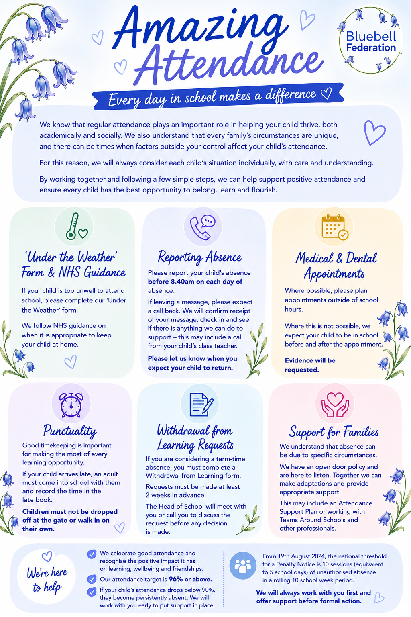

- We have different people in our school who champion positive attendance and below outlines their roles and responsibilities. (See Appendix J for an enlarged version)
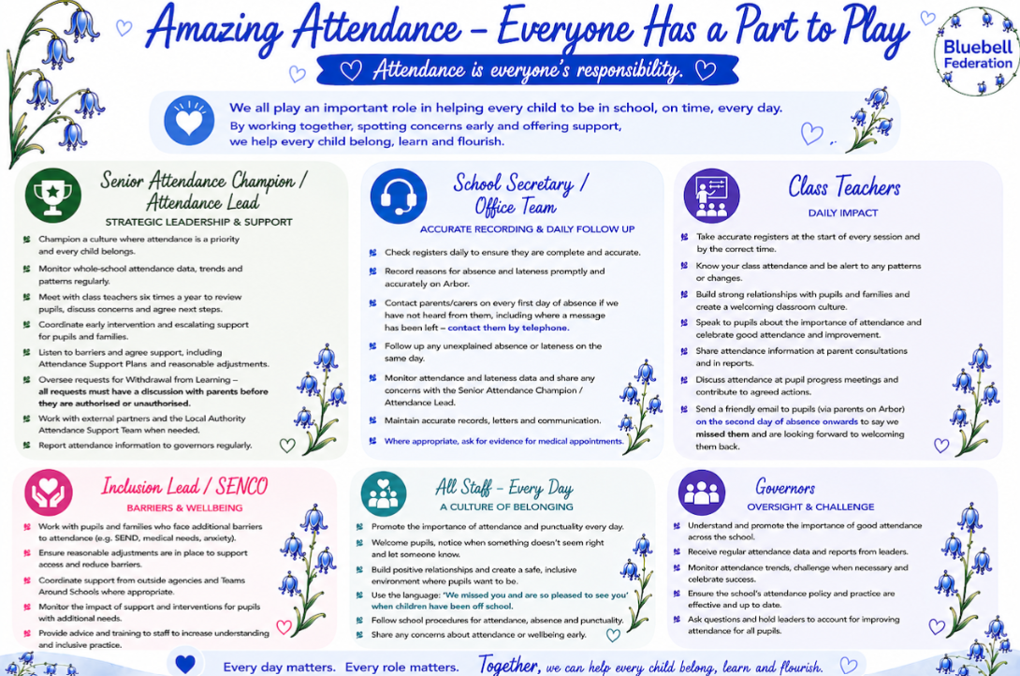

- We recognise positive attendance and celebrate it through these rewards
- Celebrate excellent attendance by displaying and reporting individual and class achievements
- Reward children with ‘improved’ attendance (however big or small) extra marbles for jar/sticker/house points.
- Birthdays are celebrated in school with birthday sashes, candles, a birthday card and a line pass
- Hold regular Attendance Challenge days/weeks- with prizes for individuals and classes (prizes special activities, not additional play)

Appendices

Appendix A: East Sussex County Council’s Penalty Notice Procedures for Schools and Academies
- Appendix 1: Withdrawal from Learning Form (see below)
- Appendix 2: Template letter to Parent - to accompany a declined absence
- Appendix 3: Request Form to Issue a Penalty Notice following a Planned Absence (i.e. holiday)
- Appendix 4: Template letter to Parent where it is believed a holiday has been taken but was not requested in advance
- Appendix 5: Template letter to invite parent to an attendance meeting
- Appendix 6: Template letter to parent following attendance meeting
- Appendix 7: Template of Attendance Support Plan
- Appendix 8: Template letter to parent who failed to attend attendance meeting
- Appendix 9: Request Form to Issue a Notice to Improve/Penalty Notice for persistent unauthorised absence.

Appendix B: Attendance Policy Quick Guide for Parents (see below)

Appendix C: Attendance Codes (see below)

Appendix D: NHS Guidance: Is my child too ill for school?

Appendix E: East Sussex County Council Attendance Intervention Pyramid (see below)

Appendix F: East Sussex County Council Penalty Notice Code of Conduct for Unauthroised Absence (Youtube)

Appendix G: DfE & Children’s Commissioner: ‘Illness Absence Guidance’ for parents

Appendix H: DfE Guidance Summary Responsibilities for School Attendance

Appendix I: Amazing Attendance Information leaflet for parents (see below)

Appendix J: Roles and Responsibilities (see below)

Appendix K: ‘Under the Weather form’ (see below)

Appendix L: Celebrating positive attendance rewards (see list below)

Appendix A (1): Withdrawal from Learning form


Withdrawal from Learning Application:
For Exceptional Circumstances

Did you know that across the year there are just 190 school days? That means there are already 175 days set aside for weekends, holidays, family visits and rewarding days out. We believe every school day counts to give your child the greatest opportunity of attaining a good education and to support a happy and healthy future.

With 175 days already marked out as ‘non-school-days’, you should have an exceptional reason to withdraw your child from school. The following are not considered to be exceptional circumstances and are likely to be rejected and unauthorised:

- Trips to visit family/friends
- Your child’s birthday
- Cheaper family holidays
- Tickets to sports/culture events

100% is recognised as an expected level of school attendance. Five days of school equates to 25 hours of learning, catching up with extra work out of school is unrealistic.

The vast majority of headteachers do not authorise any absence in term time, in fact, many schools refused 100% of requests last year. We strongly recommend you discuss your absence request with the school in the first instance.

Think twice about whether you want to proceed. Your child has the right to a full-time education and the opportunities that this can bring. We hope that you will work in partnership with us to make sure that your child attends school every day, allowing them access to the education they deserve.

To be completed by parent/carer:

Child’s Name: …………………………………………………………….. Tutor Group/Class ……………………………

Date of withdrawal from learning: ………………………………………………………………………………………….

Date of return to learning: ……………………………………………………………………………………………………..

Total number of learning days missed: ……………………………………………………………………………………

Reason for absence:………………………………………………………………………………………………………………...

…………………………………………………………………………………………………………………………………………………

…………………………………………………………………………………………………………………………………………………

Declaration:-
By completing and submitting this form I understand that if the request is unauthorised the Legal Interventions Team at East Sussex County Council will be notified of the absence taken and a legal intervention may be instigated in the form of a Penalty Notice. I also understand that if a Penalty Notice is issued it will be to each parent for each child taken out of school. I also acknowledge the following:-

- A limit of no more than 2 penalty notices will be issued to the same parent for the same pupil within a 3-year rolling period will apply from 19 August 2024.

- The first penalty notice issued to the parent for that pupil will be charged at £160 if paid within 28 days reducing to £80 if paid within 21 days.

- Where it is deemed appropriate to issue a second penalty notice to the same parent for the same pupil within 3 years of the first notice, the second notice is charged at a flat rate of £160 if paid within 28 days.

- A third penalty notice will not be issued within a 3-year period. Therefore, in cases where the threshold is met for a third (or subsequent) times within those 3 years, a penalty notice cannot be issued, and alternative action will be taken instead. This will often include considering prosecution but may include other tools such as one of the other attendance legal interventions.

- I understand that if I do not pay the penalty notice this will result in legal action.
Name of Parent/Carer:…………………………………………………………………………………………………………..

Signed: .......................................................................................................
Date: ………………………………………………………………………………………………………………………………………..
Home Address: ……………………………………………………………………………………………………………………………
…………………………………………………………………………………………………………………………………………………..

………………………………………………………………………………………………………………………………………………………………

Please ensure you are giving at least 14 day’s notice of the proposed absence.

Head teacher decision:
Name of child: …….…………………………………………………………. Class/Year Group………………………….
Date decision form sent home: …………………………………………………………………………………………………
Authorised: Your request has been authorised for the following dates: ……/…../…… to ……/……./……..
Unauthorised: Your request has been unauthorised for the following dates: ….…/……./…… to ……../………/……..
A Penalty Notice WILL / WILL NOT be requested (delete as appropriate)

Head teacher signature ………………………………………………………………………………………………….………..
Date: … ……………………………………………………………………………………………………………………………………….

Appendix B: Attendance Policy Quick Guide for Parents

The Bluebell Federation Attendance Policy Quick Guide for Parents

We expect pupils to attend school 96% of the academic year.

How can I support my child’s attendance and punctuality?

- Ensure your child arrives early or on time for school every day and is ready to learn. Arriving after registration is recorded as an unauthorised absence. Pupils must be in class/form time ready to be registered by 8.55 am.
- If your child appears to be only slightly unwell, send them in to school. We have staff who will contact you if their condition deteriorates [see NHS guidance]. You may complete the ‘Under the Weather’ form to ask staff to keep an extra watchful eye on them whilst they are in school.
- Book any medical appointments outside of school hours or during the school holiday where possible. If this is unavoidable, please book for as late in the afternoon as possible and inform the school of appointments in advance.
- Supply a copy of the appointment or hospital letter prior to them leaving school, if your child has an appointment during school hours.

What should I do if my child is not ‘fit’ to go into school?
‘On the day’ absences:
On each day your child is unfit to come to school, please report this absence to let us know. In the message you must leave your child’s full name, class and give the specific reason for absence. The School Secretary will call you back if you have left a message to discuss the absence in more detail and the information you give will be recorded on our official register.

Leave of Absence
There may be exceptional circumstances where you need to request a leave of absence for your child.
Please use our ‘Leave of absence request’ form to make these types of requests (Appendix A).
The form should be submitted a minimum of 2 weeks in advance of the leave of absence, via the school office. You will receive a letter in response, to advise if the request has been approved or not approved.

Appendix C: Attendance Codes

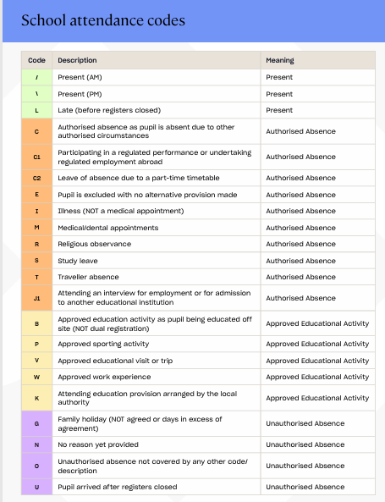
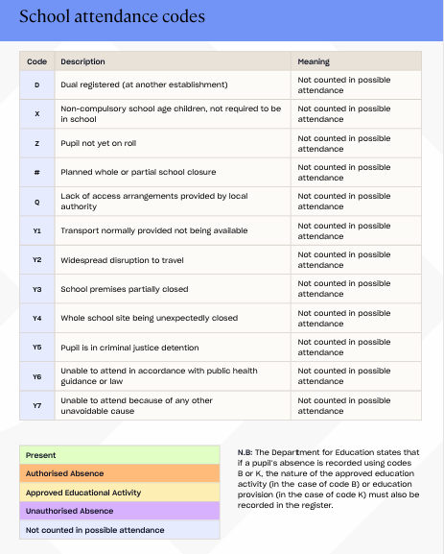

Appendix D: NHS Guidance: Is my child too ill for school?

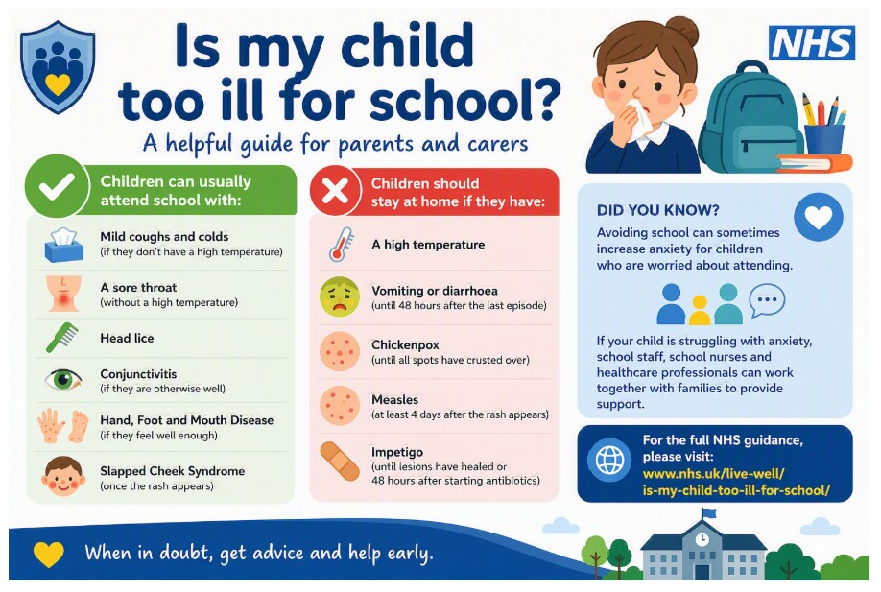
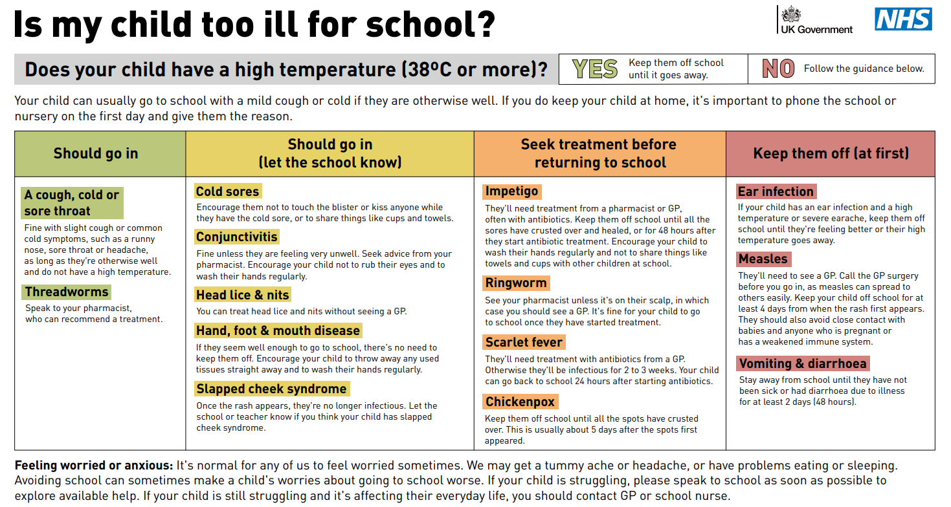

Appendix E: ESCC Attendance Intervention Pyramid

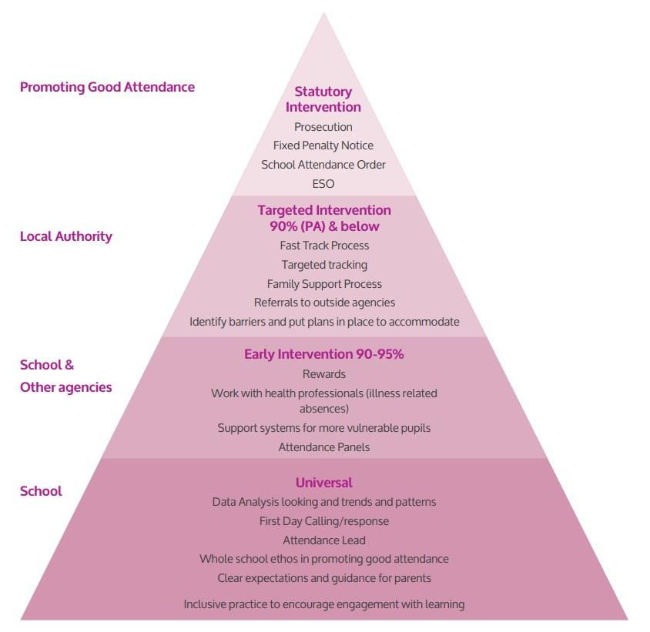

Appendix F: Attendance Management Flowchart
SCHOOLS : monitoring and tracking of attendance at whole school level (EEF).
Named SPOC will hold attendance Targeting Support Meeting to discuss trends, systems, data and emerging school needs, including pupil cohorts and individual pupils who are severely and persistently absent (SA/PA)
Actions identified by School/AST SPOC including signposting for support.

Tier 1: 100% - 93% / Universal
Schools monitor, track and implement early intervention strategies including recognising improved attendance.
The DfE have a set of steps to support.
School Action
AST
Action
Tier 3: 79% - 61% / Targeted Plus
School and AST SPOC identify individuals / targeted groups with entrenched barriers, where TASS School Attendance Liaison Practitioner (SALP) may be considered for additional support.
School to continue to hold timely support plan reviews, up to a maximum of 12 weeks and implement supportive interventions and evidence strategies and their impact in existing plans.
Where all supportive measures have been exhausted, a formal attendance contract should be implemented/ considered.
Where there is no improvement and attendance remains a concern, school to consider next steps in discussion with the attendance SPOC, including a LA multi-agency response, and the statutory attendance interventions.
School to consult attendance SPOC when legal interventions are being considered as the next step. A legal interventions referral form (LIP) will be provided to the school by the attendance SPOC. The attendance SPOC will be available to review the LIP referral form prior to submission to the LA.
Tier 4 : 60% > /Specialist
Early Help Keywork Level 2. Up to 5-month intensive intervention.
- Criteria for referral: All supportive measures detailed in Tiers 1-3 must be completed and referral criteria met for referral to be considered and Attendance support plans to be submitted. If a referral is declined IAG will be provided by SPOA/ EH to the referrer.
- Attendance must be 60% or below for 10 consecutive academic weeks
- School make referral SPOA Portal using - Contacting the Single Point of Access (SPoA) | East Sussex County Council.
- Schools will be expected to continue to support and retain a relationship with the family alongside EH to ensure smooth handovers at the end of intervention and actively participate in multi-agency and professional’s meetings including EH review and closure meetings as part of a collaborative approach.
Supporting families with complex needs | Family hubs

AST SPOC is ab;e to attend and support with advice and guidance CIN/CP/YJS/CLA multi-agency meetings where attendance is a cause for concern.
Attendance Targeting Support Meetings will be scheduled as appropriate.
SPOC available for advice/ guidance/ training support to staff. Daily Attendance Helpline (01273 481967) is available.

Tier 2: 92% - 80% / Targeted
Where complex or additional SEND needs are identified, school to East Sussex County Council suggested strategies . School identifies cohorts for in-school group support/mentoring support/parent-school meetings. Additional support if required can be sought through the school’s attendance SPOC.
School completes an Assess Plan Do Review form and pupil voice for pupils or an attendance support plan with 92% and below attendance, and capture parent views.
School to hold reviews, a minimum of every three weeks, to implement supportive interventions.
Where there is no improvement and attendance remains a concern, school to consider next steps, in liaison with their SPOC or via the attendance advice and guidance line.
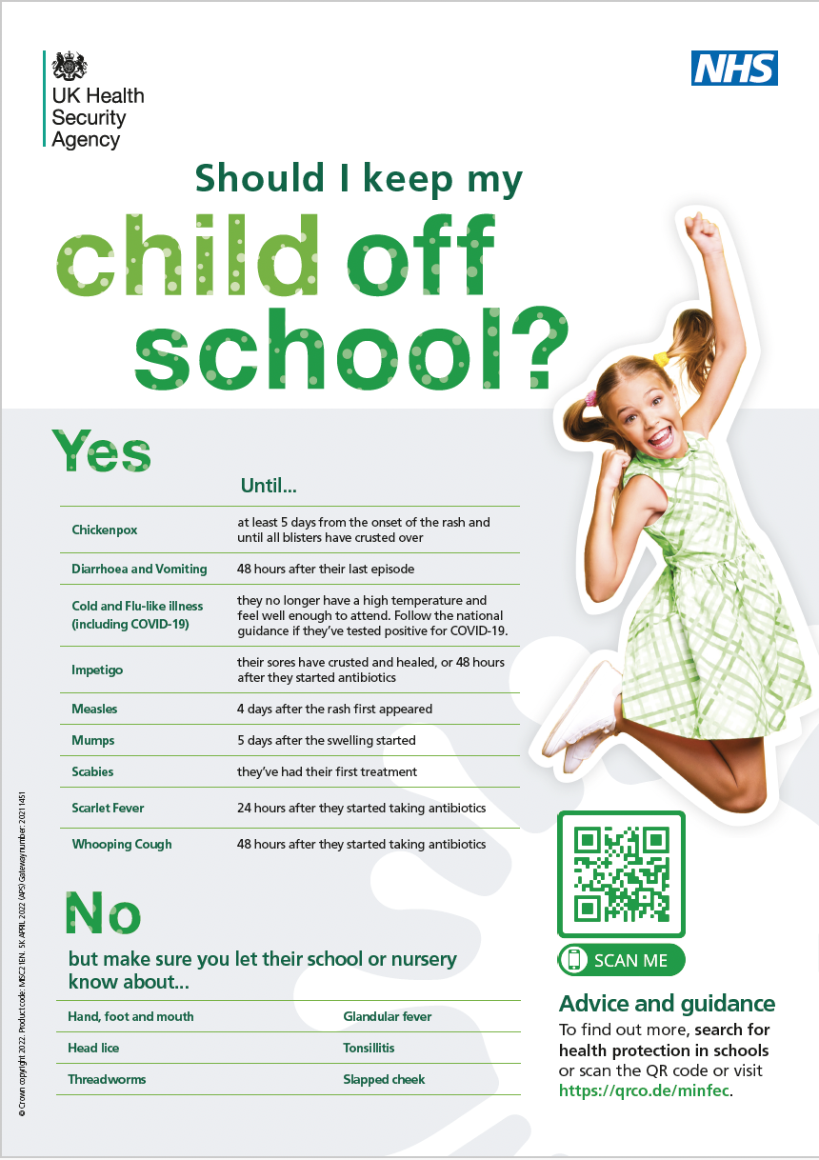
Appendix I: Amazing Attendance Information leaflet for parents
Appendix J: Roles and Responsibilities
Appendix K: ‘Under the Weather’ form

FEELING UNDER THE WEATHER?
A quick form to help us support your child in school

We understand that children can sometimes feel a little under the weather without being too unwell to attend school. If your child is well enough to come into school but needs a little extra support, please complete this form so our staff can keep an eye on them and respond quickly if they feel worse. Please use the NHS guidance “Is my child too ill for school?” if you are unsure whether your child should attend.
1. ABOUT YOUR CHILD
Child’s name: ___________________________________________________________________
Class / Tutor Group: _____________________________________________________________

2. ABOUT YOU
Parent / Carer name: _____________________________________________________________
Relationship to child: _____________________________________________________________

3. HOW IS YOUR CHILD FEELING TODAY?
Please describe symptoms: ________________________________________________________
_____________________________________________________________________________
Long-standing medical condition? ☐ No ☐ Yes — If yes, please add relevant information: _____________________________________________________________________________

4. MEDICATION
Medication taken before school? ☐ No ☐ Yes
If yes: name / time taken: ________________________________________________________
Anything else we need to know: _____________________________________________________

5. IF YOUR CHILD BECOMES MORE UNWELL
Parent / Carer to contact: _________________________________________________________
Telephone number: ______________________________________________________________
Alternative number: _____________________________________________________________

6. ANYTHING ELSE WE SHOULD KNOW?
Please add anything that may help us support your child today:
____________________________________________________________________________
____________________________________________________________________________

Parent / Carer signature: ____________________________ Date: ____________

Appendix L: Celebrating positive attendance – our rewards

- Celebrate excellent attendance by displaying and reporting individual and class achievements
- Reward children with ‘improved’ attendance (however big or small) extra marbles for jar/sticker/house points.
- Birthdays are celebrated in school with birthday sashes, candles, a birthday smelly certificate and a line pass
- Hold regular Attendance Challenge days/weeks- with prizes for individuals and classes (prizes special activities, not additional play)

